Introduction:

This is a Hi-fi webstore.

Providing a test soundtrack, which is from online recordings with a human-like headset wearing the headphones from the product catalog, although the actual feeling(feel of listening) will not be the same as the reality, but it is just for a reference.

The additional function:

There is a page used for choosing different tones, which is an audition room, there is an amplifier setup(decoration) in the middle of the room, which allows users to select different tones to listen to different styles of music they prefer.

Explain: a function to provide different tones for the user to choose, after the selection of those tones, they will be subdivided and ultimately will come out to a few models of headphones for the user to choose from that fits their style. Earphones recommended to the user are according to the three tuning styles of headset e.g. bright, flat, bass, etc.

Website Structure:website structure diagram


Website Layout:

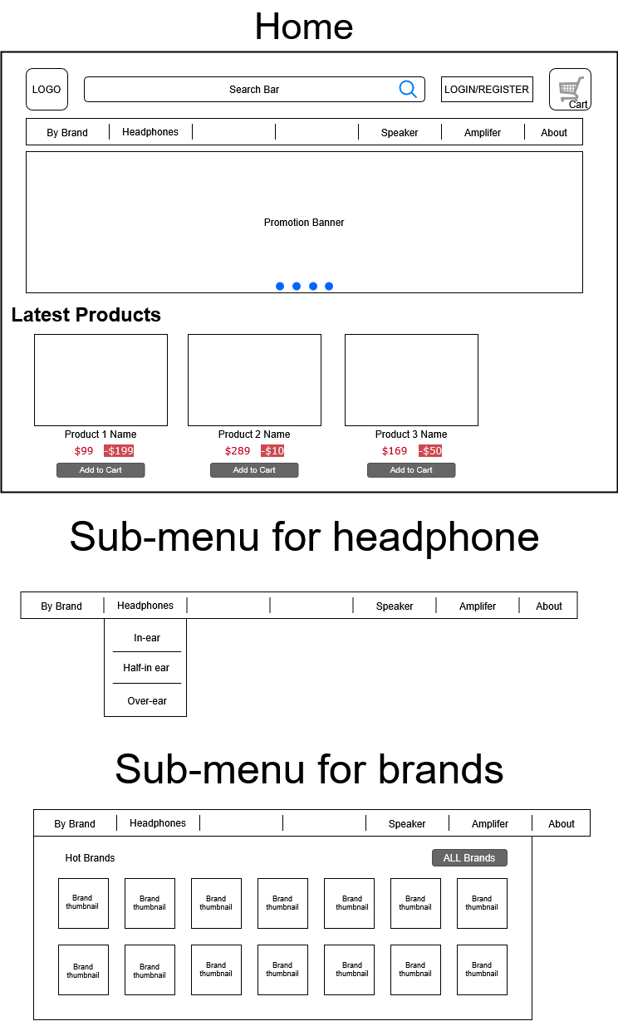

一張含有 文字, 螢幕擷取畫面, 數字, 字型 的圖片

AI 產生的內容可能不正確。

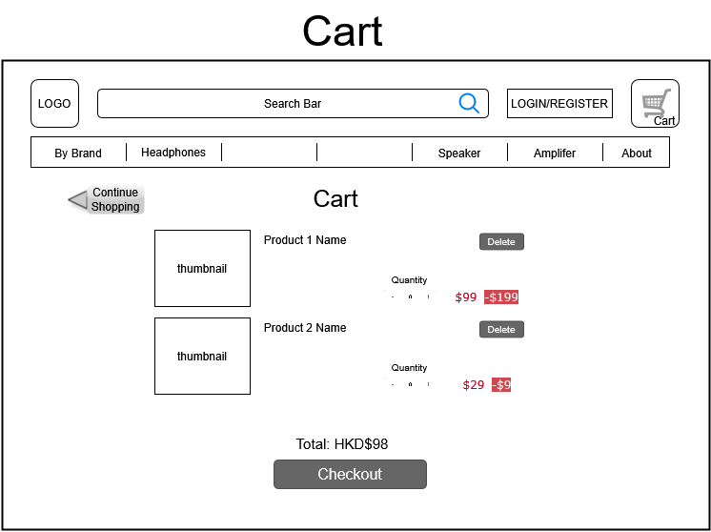

一張含有 文字, 螢幕擷取畫面, 數字, 字型 的圖片

AI 產生的內容可能不正確。

